PERFORMANCE MANAGEMENT Phase II-A Report 64
Generally, from closed plans unless noted. Must contain sub-goal (not learning activity) with a status of “In Progress” or “Completed” with no cancelled outcomes.
Generally, the numerator = who met the criteria / denominator = who COULD have met the criteria

Dimension | Made up of | What is measured | From where? | NOTE
Customer Service  40% | 1. Customer satisfaction  (accounts for 15% of the 40) | Learner rates 4 or 5 on recommending program | Exit form  /Learner exit& satisfaction | From closed service plans
Numerator: rating of 4 or 5
Denom= All plans with 1-5 ratings
Learner response rate= actual # of learners who responded
 | Target: 90% of learners satisfied
 | 2. Service coordination  (accounts for 25% of the 40) | Referrals into our program, during service and at exit | In: registration form, then cams.  During:  recorded in cams  Exit:  recorded in cams  Numerator= # of plans with at least one “countable” referral  Denom= total # of plans closed within report period  Actual= % of plans with a supported referral | From service plans closed  in Report period  note – report 60B won’t match  because it is based on active plans  + closed plans if they were active  during report period.
Target: 50% of closed files have supported referrals
See page 2 for referrals info

Referrals in do not count if from: other LBS providers ,word of mouth; media; or no response
(recorded but not part of the measurement)

Referred in: closed service plan and had to have had at least one competency
Formally referred, not word of mouth
Referrals out count if:
Registered in Education – recognized high school or equiv.
Registered in Training – incl. LBS service provider – ie Learning Centre
Registered in ES – (Employment service)
Registered with Comm. Service that support learning

Referred out : closed service plan and had to have had at least one competency
Learner confirmation that they are receiving services as result of LBS Service Provider
Referred out – community resources: learner confirmation that they are receiving service supporting achievement of goals as result of LBS Service Provider

Dimension | Made up of | What is measured | From where? | NOTE
Effectiveness  (50%) | 1. Suitability/  Learner Profile  (accounts for 20% of the 50) | Who we are serving | Registration form (Cams person home page and client summary  Numerator= # of suitability indicators  Denom= # of plans closed in report period  ACTUAL: avge % of suitability indicators PER learner  [sum of indicators divided by sum of closed plans divided by 10 (the number of indicators)] | From closed service plans
TARGET: 30% of learners have an average of 3 suitability indicators
SUITABILITY INDICATORS
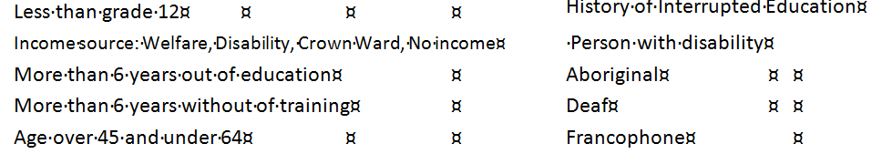
Disability defined on next pg
(Note – advised TCU (Brian) that the data dictionary does not include “no income” as one of the suitability indicators, although the report seems to pick it up for performance mgmt.)
Item 2 of Effectiveness on page 5
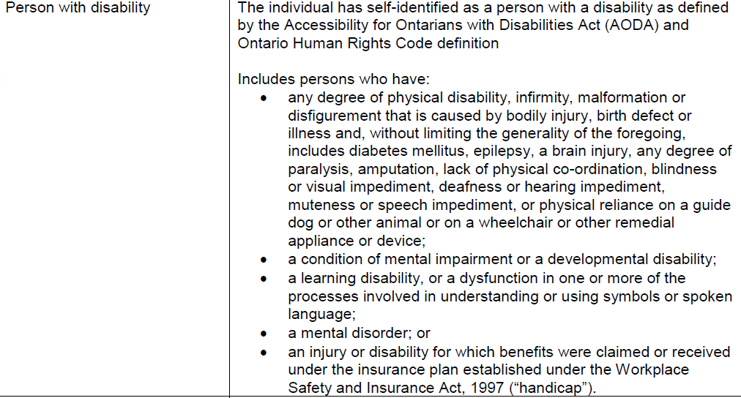
Use this to help a learner identify with a disability – many don’t know what is actually included
Dimension |  | Made up of |  | What is measured |  | From where? |  | NOTE
Effectiveness  (50%) |  | 2.Learner Progress  (accounts for 30% of the 50) |  | Learners who have successfully completed at least ONE milestone related to goal path |  | “Attained” Competency plan item ie read continuous text, manage money; etc(not incl. learning activities)  Numerator=# of plans with one competency plan item outcome of attained, entered during the report period  Denom= # of plans that were active or closed within the report period.  Actual=% of plans with at least one milestone completed (num/den) |  | From active and closed service plans  (report 60B should match – same report criteria)
Target: 60% achieving at least one milestone
Dimension | Made up of |  | What is measured |  | From where? |  | NOTE
Efficiency  (10%) | Learners Served  (accounts for 10%) |  | All learners with active service plan  Incl. at least one milestone in progress or completed in cams |  | Defined start and end dates on a competency sub goal.  Incl new and carry over |  | From active and closed service plans  if learner was served within the same fiscal year
learner #s could be increased by knowingly adding a learner that has no expectation of completing a milestone, but it will have a detrimental effect on learner progress results (due to progress denominator being based on the total # plans that COULD have met requirements).  Learner progress has a heavier weight (30%) |  |  |  |  | Calculation example:  Annual target number 182 X pro-rated months ie, report is YTD apr-jun=3/12 or .25  182 X.25=45.5  YTD All Participants NUM is then divided by above result. Eg, all participant # is 25:  25/45.5= 55% Actual.
Target: 100% (135 learners)
New= new learner with serv. plan created in current reporting period. \comes from SP home pg, case details, start date field
Carry over= service plan created before current report period and still active at start of new report period

Numbers come from LBS guidelines pg 76
C:\Users\admin\Desktop\REPORTS\Detailed service quality #64\Explanation.docx

