C:\Documents and Settings\cparliament\Local Settings\Temporary Internet Files\Content.IE5\ABRJ95EI\MC900078768[1].wmf

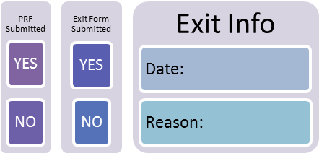

Office Use Only

My Upgrading Plan

Name

My Goal

My Learning Style is:

🞏 Visual (watching or seeing the process)

🞏 Auditory (hearing a lesson)

🞏 Kinesthetic (hands on practice)

Upgrading Start Date: ________________

Expected Completion Date: ________________

My Credit Course Information: 🞏 I have my high school diploma or 🞏 I have ___ high school credits.

After my Upgrading I will be working on 🞏PLAR credits or 🞏 Maturity Credits or 🞏Other

I was referred to Upgrading by: 🞏Learning Centre 🞏OW 🞏Employment Services or

🞏Other

Comments regarding circumstances that may affect my Upgrading experience (medical condition, other commitments, attendance):

My Instructor referred me to the following services:

|  |  |  |
| --- | --- | --- |
| Learning Activities and Milestones I am working on(Include Level and Number) | Expected Completion Date | Date Achieved |
|  |  |  |
|  |  |  |
|  |  |  |
|  |  |  |
|  |  |  |
|  |  |  |
|  |  |  |
|  |  |  |
|  |  |  |
|  |  |  |
|  |  |  |
|  |  |  |
|  |  |  |
| Exit Assessment: 🞏Culminating Task 🞏Transition to my Goal Checklist or 🞏Other |  |  |

C:\Documents and Settings\cparliament\Local Settings\Temporary Internet Files\Content.IE5\5IOI56AX\MC900078625[1].wmf

I agree to the content of this Plan.

Learner Signature: Instructor Signature: Date: