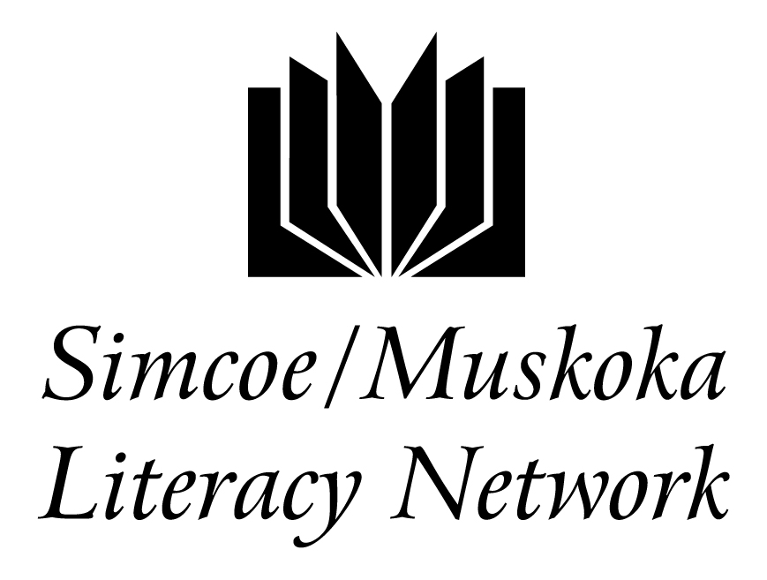
Simcoe/Muskoka Literacy Network E-Bulletin
March 2017

Welcome to Simcoe/Muskoka Literacy Network’s E-Bulletin, a round-up of information and news of interest to agencies supported by SMLN. Time-sensitive information may be included, but will also be distributed by separate e-mail message as needed. All hyperlinks were working properly at the time of publication.

Please let us know by the end of each month if you have anything you would like us to include in the next e-bulletin.

------------------------------------------------------------------------------------------------------------------
Table of Contents

1. Checkered Door 1

2. Ministry Reporting Dates 2

3. SMLN consultation with LSPC members 2

4. ICT – where the jobs are but not the people 2

5. Ministry of Education Adult Education Strategy 3

6. Resources and Professional Development 4

7. Essential Skills for Personal Success 5

8. Employment Ontario news 6

------------------------------------------------------------------------------------------------------------------

- Checkered Door
With files from Judy DesRoches

Some literacy service providers struggle with how to help clients when their learning barriers don’t specifically fit within what LBS programs can provide. For example, people with autism may benefit from additional specialized support.

The “Checkered Door is a new venture from Careers for Inclusion in Barrie. It is a Social Development Program for Youth with Intellectual Disabilities including Autism Spectrum Disorder, ages 18-29. This group of youth is permitted to stay in secondary school until age 21 without access to the specific social skills development required to transition to adulthood. A gap in service has been identified and teachers/parents/caregivers are seeking resources for this essential training. Social skills development is important for individuals with Autism Spectrum Disorder and other intellectual/developmental disabilities to mature and self-identify/self-regulate emotions and behaviors. This training will support individuals to develop the skills required for increased opportunities for inclusion in the community and safer functioning in the home in the absence of supervision.
Please go to http://www.checkered-door.com/ for more details about the program.

Although it is a fee-based service, many people have access to the “Passport” program. http://www.dsontario.ca/files/www/passport_guidelines_en.pdf

- Ministry Reporting Dates

Several years ago, QUILL created a calendar showing all the reporting dates for the Ministry reports. Even though the Ministry of Advanced Education and Skills Development (MAESD) now includes these dates in our agreements, QUILL has sent out the calendar foe the new fiscal year. Please download from http://literacynetwork.ca/wp-content/uploads/2017/03/Calendar-of-MAESD-reporting-dates-2017-2018.docx

- SMLN consultation with LSPC members
We want to thank those who participated in SMLN’s initial consultation with primarily LBS agencies at the March network-wide LSPC meeting in Orillia. We really appreciate the time you took to provide your input. Over the next few months, our Board of Directors and staff will be reviewing your comments and suggestions and may discuss some items further at future meetings. We also plan to consult with other Employment Ontario partners.

- ICT – where the jobs are but not the people
Article by Marc Saltzman, Special to the Star, Mon., March 13, 2017

How’s this for a disconnect: Canada’s youth unemployment rate in on the rise – 13.3 per cent compared to 12.6 late last year – yet there are many unfilled jobs, especially those related to ICT (information communications technology). According to the first-ever national digital talent strategy released in 2016 by the Information and Communications Technology Council (ICTC) not-for-profit think tank, it’s projected 182,000 skilled ICT workers will be needed in Canada by 2019, with another 36,000 by 2020. Titled “Digital Talent: Road to 2020 and Beyond,” this report urges fast and meaningful action to position Canada for success.

https://www.thestar.com/life/coursesforcareers/2017/03/13/ict-where-the-jobs-are-but-not-the-people.html

- Ministry of Education Adult Education Strategy

The Ministry of Education is managing a project looking into adult education and helping adults to successful complete their OSSD or an equivalent. The Adult Education Strategy supports the commitment made in Achieving Excellence: A Renewed Vision for Education to “ensure that the adult education system better supports adult learners in their efforts to finish high school and successfully transition to postsecondary education, training or the workplace.” The strategy provides an opportunity to explore innovative ways to reengage adult learners and build school board capacity to better assist them in achieving their goals.
A few of us have attended focus groups in Barrie and some of you might be invited to other consultations in the future. At some point all school boards in the province will be involved in the consultation phase. This presentation contains a very good description of the project.
In case you want more background information about the consultation and process, here are a couple of links with information about it.
Details of the project - https://www.eosdn.on.ca/sites/eosdn.on.ca/files/RPAE%20Project%20Description.pdf
News release from Dec 2015 from EDU - https://news.ontario.ca/edu/en/2015/12/ontario-investing-9-million-to-help-more-adult-learners-succeed.html

- Resources and Professional Development

Performance Management newsletter – February 2017
Once again, Literacy Network South Central, based in London, is taking the lead to produce performance management newsletters. The first newsletter focuses on innovation.

Innovative Work in Literacy and Basic Skills March 2017
Literacy Link South Central
Somehow, with limited funding and many responsibilities, literacy programs and literacy support organizations still manage to be innovative and creative. Some of the most innovative approaches and projects come into being because of scarce resources. Innovation can also be the result of looking at what we do in adult literacy and applying it to a new area.

This issue of the Innovation Newsletter explores innovation in several of its forms. Hopefully you will be inspired by your colleagues’ work.

Customer Service Questions
Some of you may have participated in a province-wide survey to collect questions that LBS programs are asking of customers to determine customer satisfaction and actions that can be taken to improve customer service, in the spirit of continuous improvement. Twenty-five agencies from all sectors responded. The compilation lists questions already in use by at least one agency and additional proposed questions you might consider using.

Speaking the Language: Working Effectively with Clients/Learners at Lower Levels
General overview of challenges and strategies when working with this group of learners/clients; numeracy and literacy strategies and resources; assessment and learners working at lower levels (best milestones); partnerships ideas and examples between Employment Service agencies and Literacy and Basic Skills agencies.
Webinar Recording (mp4) Presentation (pdf)

Voices of Adult Learning – videos
A set of 5 inspirational and empowering interviews with adult learners who have used literacy and essential skills upgrading to unlock their potential and achieve their goals. Each one is about 4 minutes and the learners represent a range of backgrounds, ages and goals.

Small Business Curriculum
Small Business Savvy is an exploratory curriculum for people who are considering whether starting a small business may be the right path for them. It is aligned with the OALCF. It can be used as a whole or activities can be used individually.

Using Gamification in Developing LBS Curriculum and Beyond -- Research Report and French language Executive Summary: Sommaire exécutif La ludification dans le programme AFB et au-delà (2017)
A growing trend in learning communities is to integrate gamification – the concept of applying game mechanics and game design techniques to engage and motivate people to achieve their learning goals. Gamification is about applying game mechanics and game design techniques to engage and motivate people. This paper reviews aspects of gamification to be used, when possible and appropriate, for curriculum development, and to enhance Literacy and Basic Skills (LBS) service delivery by its incorporation into other program elements.

Differentiated Instruction
The use of differentiated instruction in LBS classrooms, small groups and one-to-one tutoring is critical to working effectively with adult learners. In this report, Literacy Link South Central investigates reasons for, and effective methodologies of, providing alternative avenues to learning for different students. It’s important to note that differentiated instruction is not the same as individualized

Mental Health Guide for Practitioners
Reminder about the upcoming 2-hour on-line workshop on Project READ’s newly-developed Mental Health Guide for Practitioners. The workshop will be offered 4 times:

Tuesday, April 18th @ 1:30 pm
Thursday, April 20th @ 9:30 am
Monday, April 24th @ 1:30 pm
Wednesday, April 26th @ 9:30 am

Registration will be coming out shortly.

- Essential Skills for Personal Success

Just a reminder to LBS agencies that there is still time to complete the survey sent by Literacy Network Northeast to determine interest in reproducing/updating and translating their resource: “The Essential Skills Link”.
For those of you who are unfamiliar with the project, you can find it at: https://www.northernliteracy.ca/article/-156.asp
The 4 modules in the curriculum include: Manage my Basic Needs; Manage my Health; Manage Personal Issues and Contacts and Participate as a Member in my Community.

- Employment Ontario news

March 2017: | EOIS/2017-5 Bulletin: System Performance  FS Connexion/2017-1 Bulletin
March 2017: | Memo: Revised LBS guidelines for service providers and support organizations  Note de service: Directives révisées aux fournisseurs de services et aux organismes de soutien du Programme AFB

-----------------------------------------------------/// -------------------------------------------------------
Compiled by Simcoe/Muskoka Literacy Network
575 West St., S, Unit 15, Orillia, ON L3V 7N6
Tel: 705-326-7227 toll-free: 1-888-518-4788 www.literacynetwork.ca
This Employment Ontario service is funded in part by the Government of Canada and the Government of Ontario and through the Canada-Ontario job Fund Agreement.

To unsubscribe from this E-Bulletin, please contact simcoe.muskoka@literacynetwork.ca.

